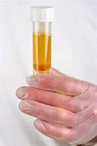  - URINE SAMPLES  WE are unable to accept a sample that has not been requested by a clinician  Any sample received without being requested by a Clinician and without an accompanying Yellow (or Blue) form, will be disposed of  Samples will only be accepted if they are in an appropriate Urine Sample Container, otherwise they will be disposed of  If you are Female & 18-65 years, please speak to your chemist in the first instance as they may be able to issue antibiotics over the counter. | Think you have a Urine Infection?  ____  Please complete a Patch via the Practice website  ____  Some urinary symptoms can resolve just by increasing fluid intake, or using remedies such as Cranberry juice/sachets or Citric Acid sachets, available from your chemist

